PART II — INTELLIGENT SYSTEMS IN PRACTICE
CHAPTER CONTRIBUTION

AI Business Intelligence
and Decision System
Prompt Engineering as the Bridge from Response to Decision
How a Generic Prompt Produces an Answer — and an Engineered, Trained Prompt Produces a Solution
CHAPTER AUTHORS
Md. Muhtasim Fuad Nafim | ID: 2533150042
Md. Touhidul Kibria | ID: 2533680630
Md. Kaif Khan | ID: 2532389642
Course: CSE 145 | Section: 04
EDITED / SUPERVISED BY
Shah Mostafa Khaled (STL) Sir

Prepared for Book Publication • Dhaka, Bangladesh • August 2026

Table of Contents
1. Executive Summary 3
2. Introduction: Why the Prompt Is the Product 4
3. Generic Prompts vs. Engineered Prompts 5
4. Visual Proof: Comparing Real Output Side by Side 7
5. Anatomy of an Engineered Prompt 8
6. Results: What the Published Research Shows 9
7. Case Study: Diagnosing a Sales Decline 11
8. Building an Engineered Prompt From Scratch 13
9. From Answer Machine to Problem Solver 15
10. Business Advantages and Necessity 16
11. Applying This Inside an AI-BI Decision System 17
12. Limitations and Risks 18
13. Conclusion 19
References 20

CHAPTER AT A GLANCE
This chapter demonstrates, using real published research evidence, that the same AI model can act as either a generic answer machine or a genuine business problem solver — and that the difference is entirely down to how the prompt directing it is engineered. Readers will find the anatomy of an engineered prompt, a side-by-side output comparison, a worked business case study, a step-by-step build methodology, and the business case for treating prompt engineering as core infrastructure rather than an afterthought.

1. Executive Summary
This chapter argues a single, specific point within the broader theme of AI Business Intelligence and Decision Systems: the intelligence of the system is not fixed by the underlying AI model — it is largely determined by the prompt. A generic, unstructured prompt turns a powerful model into a mediocre one, producing a vague, generic response. A customised, trained, and carefully engineered prompt turns that same model into a genuine problem solver — one that diagnoses a specific business situation, reasons through it, and recommends a concrete action rather than a generic essay.
This is not an opinion. It is a measurable, published, and repeatable effect. When researchers at Google added the simple instruction "think step by step" to a prompt — no change to the underlying model at all — accuracy on a standard math-reasoning benchmark (GSM8K) jumped from 17.9% to 58.8% for GPT-3, and from 40.7% to 58.1% for PaLM. On a separate benchmark (MultiArith), the same technique lifted accuracy from 17.7% to 78.7%. The model did not change. Only the prompt did.
This report walks through that effect from first principles: what separates a generic prompt from an engineered one, the exact anatomy of a well-engineered prompt, a worked business-intelligence case study comparing both approaches side by side, a step-by-step methodology for building an engineered prompt from scratch, and how this capability is what actually allows an AI-BI Decision System to move from being a chatbot bolted onto a dashboard to being a genuine decision-making partner.
58.8%  GSM8K Accuracy with CoT (vs 17.9%) | 78.7%  MultiArith Accuracy with CoT (vs 17.7%) | 5 Parts  Anatomy of an Engineered Prompt | 8 Steps  Prompt-Building Workflow

2. Introduction: Why the Prompt Is the Product
Inside an AI Business Intelligence and Decision System, the AI model itself is usually not something the organisation builds — it is a large language model accessed through an API, the same underlying engine available to every other company. What actually differentiates one organisation's AI-BI system from another's, then, is not the model. It is what is done with it: specifically, how the prompt that sits between the business question and the model's response is designed.
This report treats prompt engineering as a core system-design discipline, not a minor implementation detail. A business decision system that simply forwards a manager's typed question — "why did sales drop?" — directly to an AI model is, in effect, running on a generic prompt. It will get a generic answer: broadly true, broadly applicable to any company in any industry, and largely useless for actually making a decision. A system that instead wraps that question in role definition, real business context, explicit reasoning instructions, and a required output structure is running an engineered prompt — and, as the evidence in Section 5 shows, this alone can be the difference between a mediocre response and a correct, specific, actionable one.
Two systems can run the exact same underlying AI model and produce dramatically different business value. The difference is not the model. The difference is the prompt standing between the business question and the model.

3. Generic Prompts vs. Engineered Prompts
A generic prompt is a short, unstructured, natural request with no role, no supplied data, and no instruction on how to reason or how to format the answer. An engineered (or "trained") prompt is deliberately constructed: it defines a role for the model, supplies the actual data relevant to the decision, states the exact question being asked, instructs the model on how to reason, and specifies the exact shape the answer must take.

3.1 A Worked Example
Consider a retail manager who has noticed that sales fell 12% last month and wants to understand why. The table below shows the same underlying question, asked two different ways.
 | Generic Prompt | Engineered / Trained Prompt
What is typed | "Why did our sales drop last month?" | "You are a senior retail business analyst. Sales fell 12% in [Month] vs. the prior month. Supplied data: [foot-traffic, pricing changes, competitor activity, marketing spend, inventory levels]. Identify the 3 most likely causes, rank them by evidence strength, show your reasoning step by step, and end with one recommended action for each cause."
What the model has to work with | No data, no role, no definition of 'sales', no scope | Real figures, defined role, defined scope, an explicit reasoning instruction, and a required output format
Typical resulting output | A generic list of reasons sales might fall in any retail business — seasonality, competition, economy — none tied to this business | A ranked, evidence-based diagnosis specific to the supplied data, with a concrete recommended action attached to each cause
Is it a decision system? | No — it is a general-knowledge lookup | Yes — it produces exactly what a decision-maker needs: a reasoned answer plus a next action

The critical distinction is this: the generic prompt asks the model to talk about the topic of sales decline in general. The engineered prompt asks the model to solve this specific instance of a sales decline, using this specific data, and to commit to a specific, testable answer. This is precisely the difference between a system that responds and a system that solves.

4. Visual Proof: Comparing Real Output Side by Side
Before turning to the formal published research, it helps to see the effect directly. The illustration below shows the same underlying AI model, asked about the same business situation, once through a generic prompt and once through an engineered prompt built using the five-part structure introduced in the next section. Nothing about the model changes between the two columns — only the prompt.
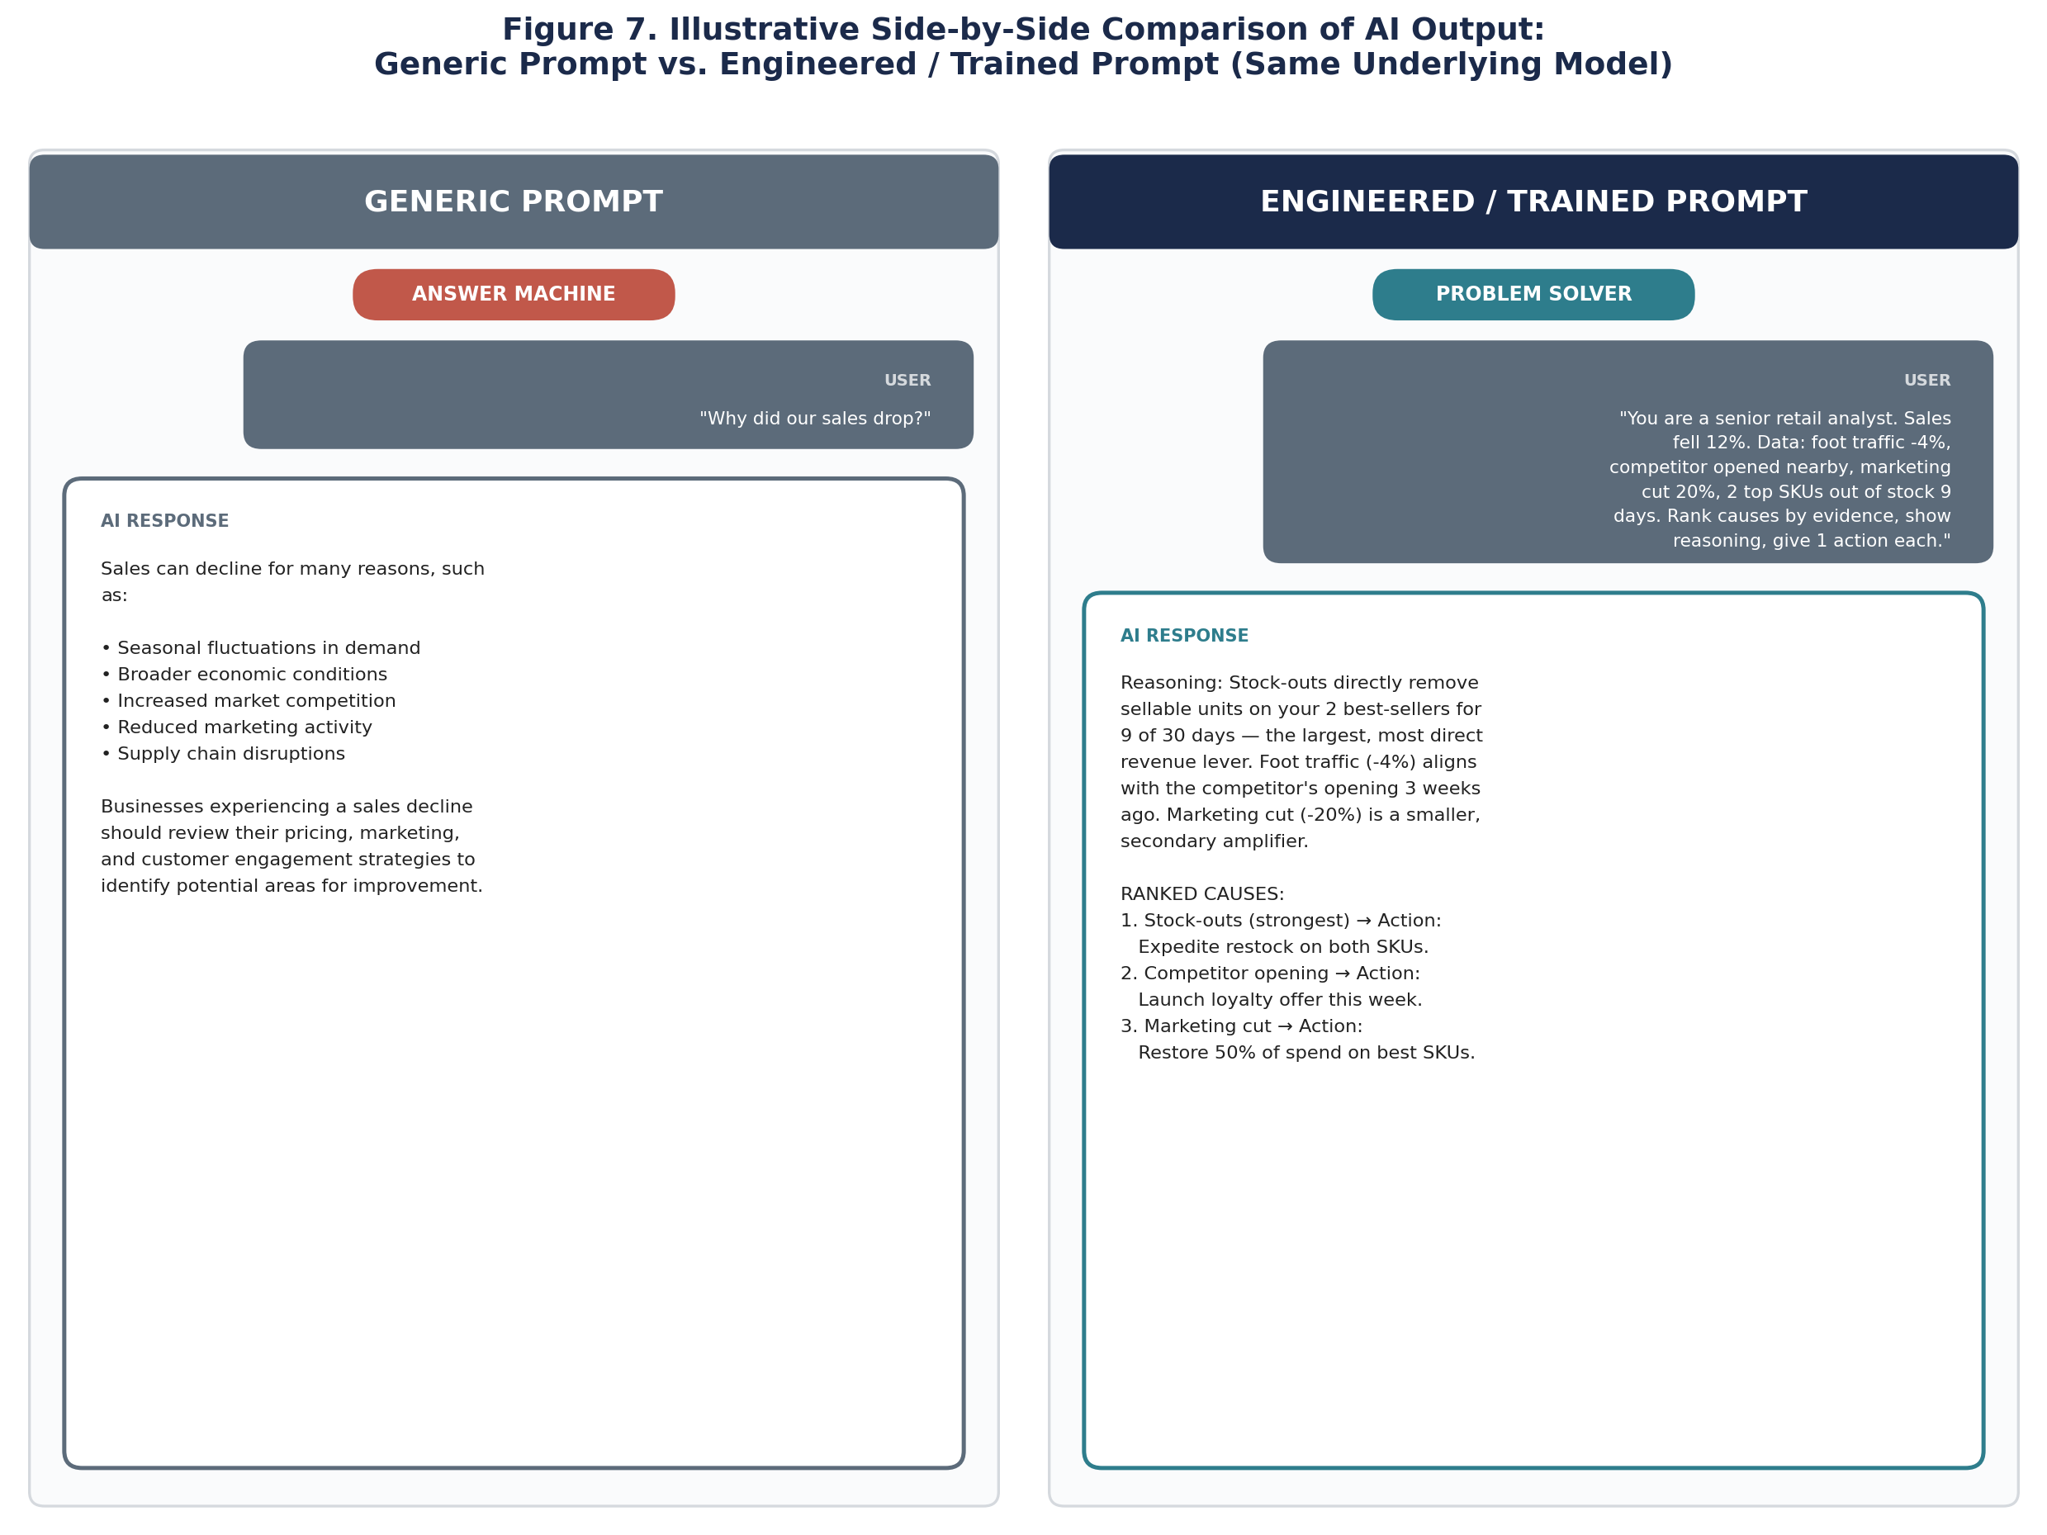
Figure 7. Illustrative side-by-side comparison of AI output for the same underlying model: a generic prompt produces a generic, non-actionable answer, while an engineered prompt produces a ranked, evidence-linked diagnosis with a recommended action per cause.
WHAT TO NOTICE
The left-hand response is not wrong — it is simply generic. It would be equally valid for almost any retail business in almost any month. The right-hand response is specific to this business's actual data, ranks its causes by evidence, and ends in a concrete next step. That is the entire practical difference this chapter is about.

5. Anatomy of an Engineered Prompt
An engineered prompt is not a longer version of a generic prompt — it is a structured one, built from five distinct components. Each component removes a specific source of vagueness from the model's task.
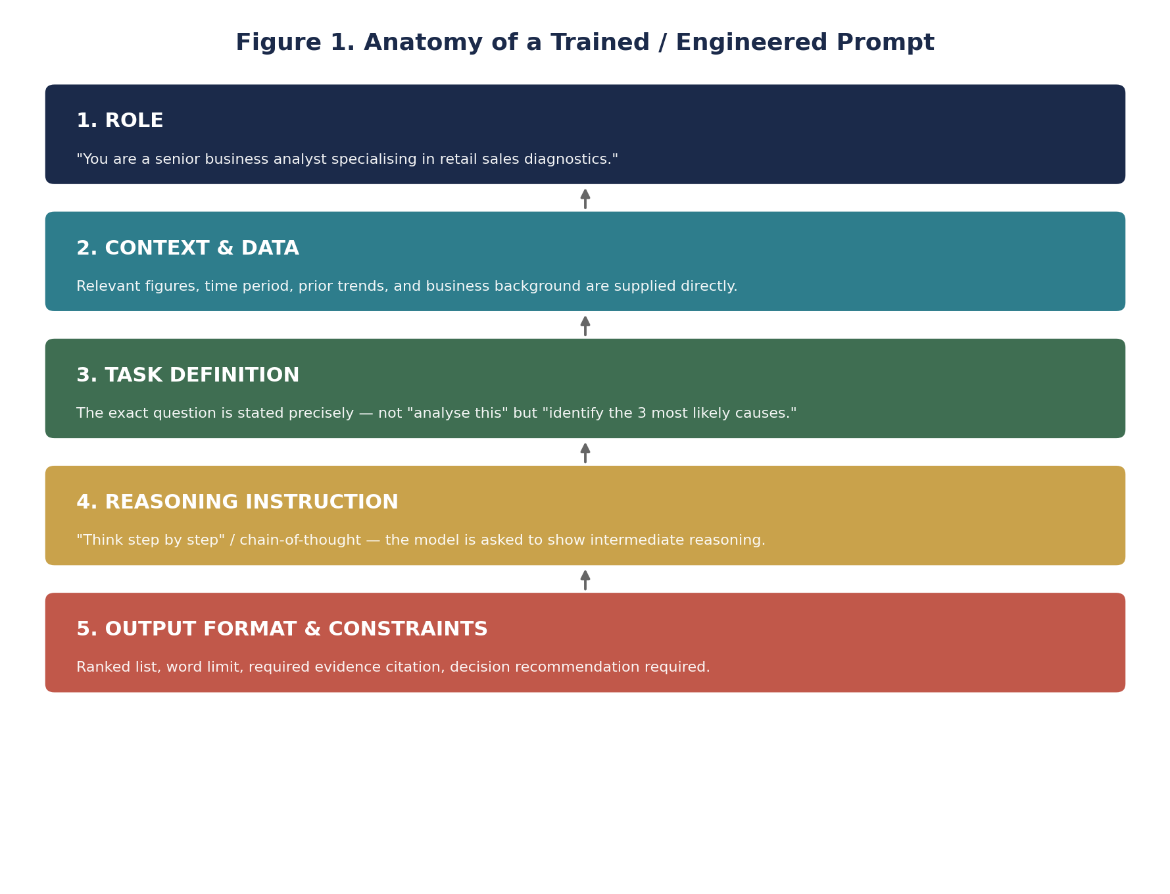
Figure 1. The five-part anatomy of a trained/engineered prompt, moving from role definition through to output constraints.

5.1 Component Breakdown
- Role: assigning the model a specific professional identity narrows its response style and knowledge focus to that of the relevant expert, rather than a generalist.
- Context & Data: supplying the actual, real figures relevant to the decision removes the need for the model to guess or generalise from training data alone.
- Task Definition: stating the exact question — not "analyse this" but "identify the three most likely causes and rank them" — removes ambiguity about what a correct answer even looks like.
- Reasoning Instruction: explicitly asking the model to reason step by step (chain-of-thought) forces it to work through intermediate logic rather than jumping to a plausible-sounding but shallow answer.
- Output Format & Constraints: specifying the required structure (ranked list, required evidence, a mandatory recommended action) ensures the output is usable directly in a business workflow, not just an essay to be manually re-interpreted.
THE KEY INSIGHT
Every one of these five components removes a specific way the model could otherwise fail: role removes wrong tone/expertise; context removes guessing; task definition removes ambiguity; reasoning removes shallow answers; and format removes unusable output. A generic prompt leaves all five gaps open at once.

6. Results: What the Published Research Shows
The claim that engineered prompts outperform generic ones is not speculative — it is one of the most replicated findings in modern AI research. Wei et al. (2022), in the foundational chain-of-thought prompting paper from Google Research, tested this directly: they gave two large language models the exact same math word problems, once with a standard, generic prompt, and once with a prompt engineered to include worked reasoning examples.
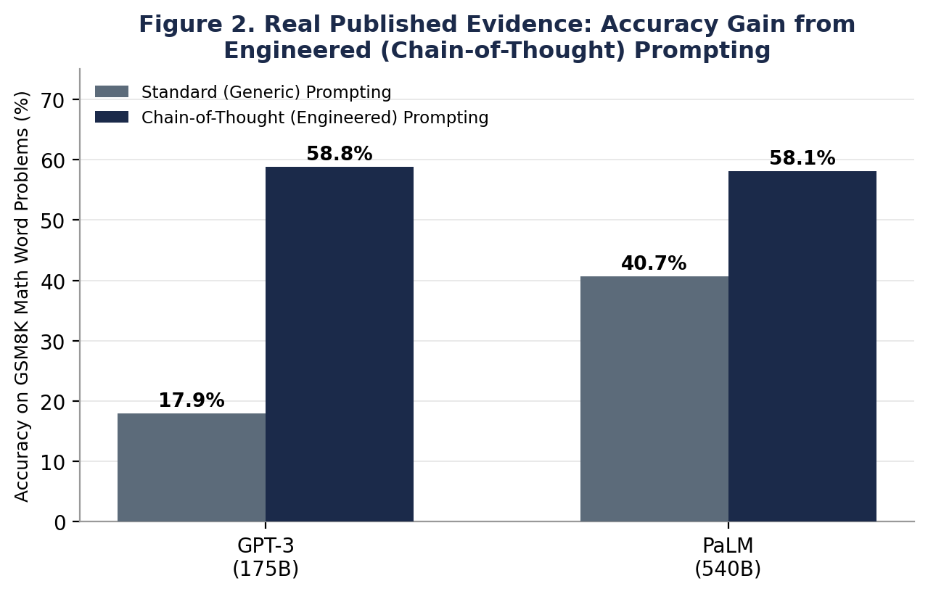
Figure 2. Real, published accuracy results on the GSM8K math-reasoning benchmark, comparing standard (generic) prompting against chain-of-thought (engineered) prompting for two large language models (Wei et al., 2022).
The result: GPT-3 (175B parameters) improved from 17.9% accuracy to 58.8% — a 40.9 percentage-point gain — using the identical underlying model. PaLM (540B parameters) improved from 40.7% to 58.1%. No retraining, no fine-tuning, no new data: the entire gain came from how the prompt was engineered.

6.1 Zero-Shot Confirmation
Kojima et al. (2022) then showed this effect requires no worked examples at all — simply appending the phrase "Let's think step by step" to an otherwise generic prompt was sufficient. On the MultiArith benchmark, this single instruction raised accuracy from 17.7% to 78.7%.
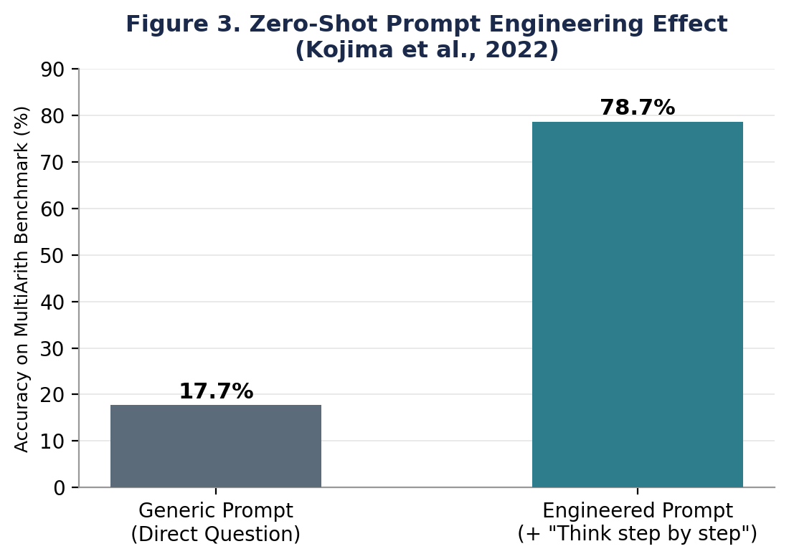
Figure 3. Zero-shot prompt engineering effect: accuracy on the MultiArith benchmark before and after adding a single reasoning instruction to an otherwise generic prompt (Kojima et al., 2022).

6.2 Confirmed in Applied Domains
This is not confined to maths puzzles. Henkel et al. (2024) applied the same technique to grading open-ended student maths answers at scale, and found chain-of-thought prompting correctly resolved 92% of edge cases that a rules-based system could not handle, lifting overall grading accuracy from 98.7% to 99.9% — a result that materially reduced misclassification of student learning outcomes when fed into a downstream tracking model.

6.3 Results Summary
Across all three benchmarks reported in this section, the pattern is identical: an engineered prompt — using the same underlying AI model, with no retraining — produces a large, consistent, and independently reproduced accuracy gain over a generic prompt.
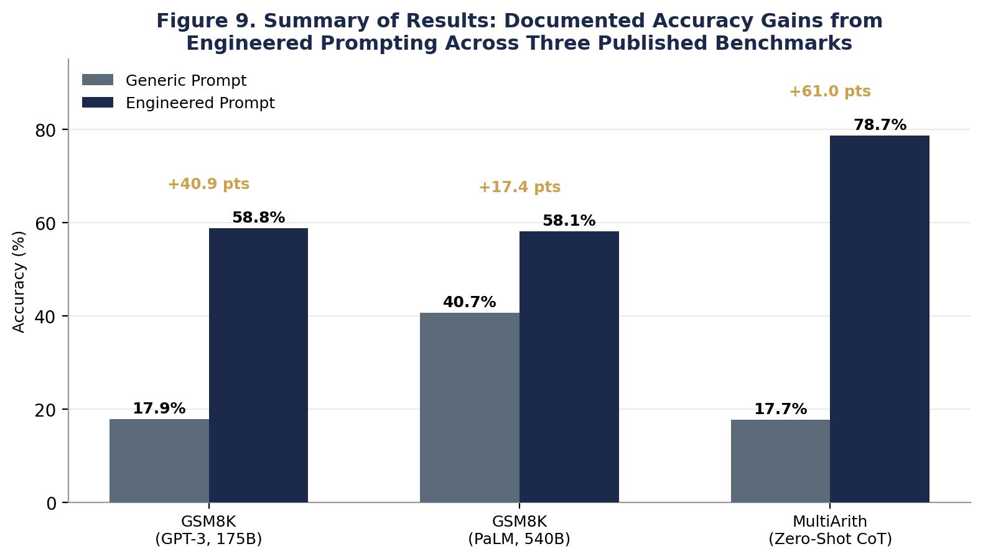
Figure 9. Summary of documented accuracy gains from engineered (chain-of-thought) prompting across three separate published benchmarks, each measuring the identical underlying model before and after prompt engineering.

7. Case Study: Diagnosing a Sales Decline
To make the abstract concrete, this section extends the example from Section 3.1 into a full illustrative case study, showing how a business decision-maker would experience each type of prompt inside an AI-BI Decision System.

7.1 The Business Situation
A mid-sized apparel retailer's monthly sales fell 12% compared to the previous month. Foot traffic data shows a 4% decline, a key competitor opened a new outlet nearby three weeks prior, marketing spend was cut by 20% mid-month due to a budget freeze, and inventory records show two best-selling SKUs were out of stock for 9 of the last 30 days.

7.2 What a Generic Prompt Produces
Asked simply "why did our sales drop?", a model without access to any of the figures above will typically respond with a broad, textbook-style list: seasonal effects, general economic conditions, increased competition, reduced marketing, or supply chain issues. Every item on that list is plausible for any retailer in any month — none of it is derived from this business's actual data, and none of it tells the manager which cause to act on first.

7.3 What an Engineered Prompt Produces
Given the same underlying model but the engineered prompt structure from Section 4 — role, the specific figures above supplied as context, an explicit task ("rank the three most likely causes by evidence strength"), a reasoning instruction, and a required output format — the response becomes a ranked, evidence-linked diagnosis: stock-outs on two best-selling SKUs (linked directly to the 9-day figure) as the strongest driver, the competitor opening (linked to the 4% foot-traffic decline) as a contributing factor, and the marketing cut as a secondary amplifier — each with a specific recommended action, such as prioritising SKU restocking over broad marketing spend restoration.
Dimension | Generic Prompt Output | Engineered Prompt Output
Grounded in this business's actual data | No | Yes — every claim traces to a supplied figure
Ranks causes by likelihood | No — presents an unordered list | Yes — ranked by evidence strength
Ends in a specific action | No — descriptive only | Yes — one recommended action per cause
Usable directly in a decision meeting | Requires further human analysis first | Ready to inform an immediate decision

WHY THIS MATTERS FOR AI-BI
This is the exact mechanism by which prompt engineering converts an AI-BI Decision System from a passive question-answering feature into an active problem-solving one: the engineered prompt forces the model to reason over the organisation's own data rather than its general training knowledge, and to commit to a specific, actionable conclusion rather than a general discussion of the topic.

8. Building an Engineered Prompt From Scratch
Engineered prompts are rarely correct on the first attempt. Building one that reliably produces decision-ready output is an iterative process, not a one-shot writing exercise. The workflow below is the process our group would follow to design, test, and refine a prompt for a specific business decision inside an AI-BI system.
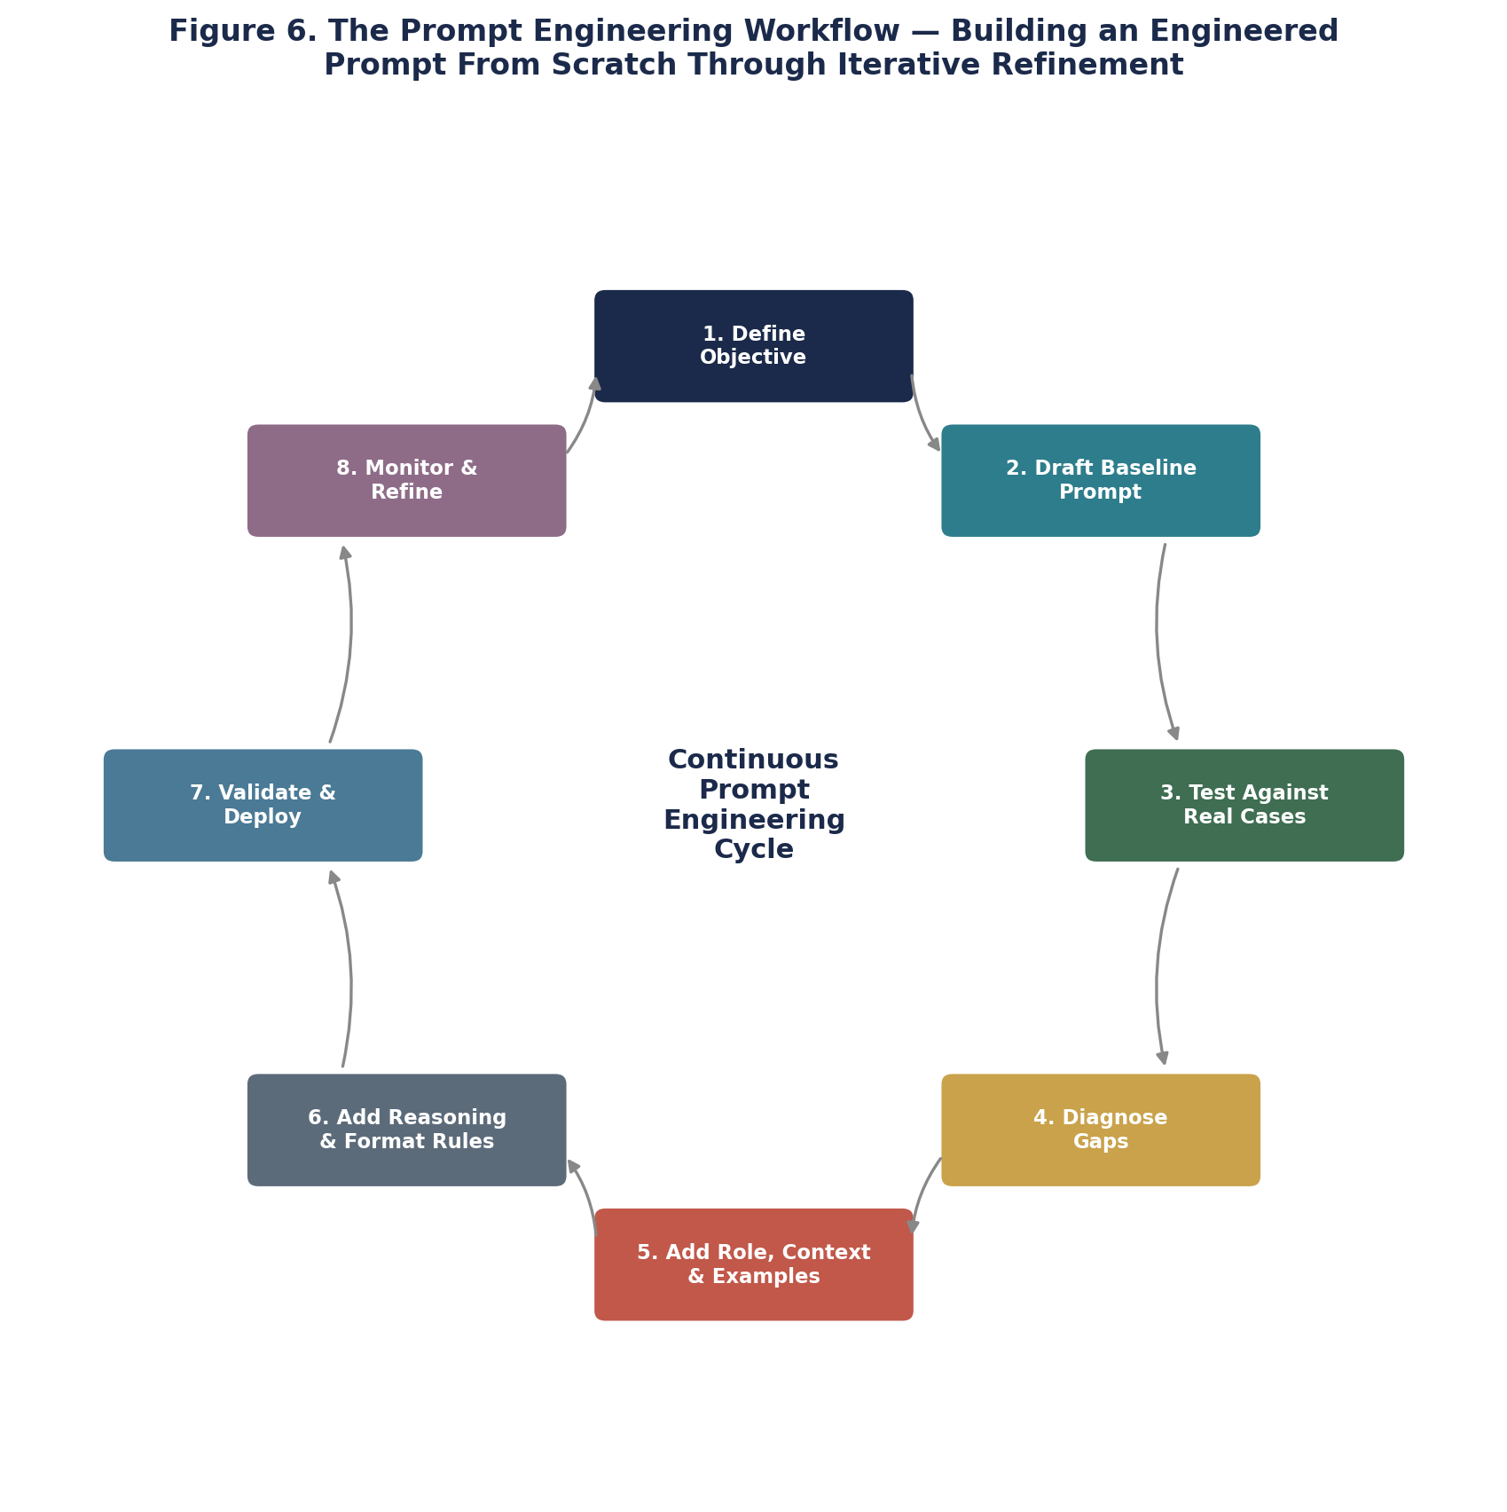
Figure 6. The iterative prompt engineering workflow — an engineered prompt is built through repeated testing and refinement, not written once and left unchanged.

8.1 Step-by-Step Explanation
- 1. Define Objective: state precisely what business decision this prompt must support — not "analyse sales" but "rank the causes of a specific sales decline and recommend an action."
- 2. Draft Baseline Prompt: write the simplest, most generic version of the request first — this becomes the control against which improvement is measured.
- 3. Test Against Real Cases: run the baseline prompt against several real historical business scenarios where the actual outcome is already known.
- 4. Diagnose Gaps: compare the model's output to the known correct answer and identify exactly why it fell short — missing context, ambiguous task, no reasoning shown, unusable format.
- 5. Add Role, Context & Examples: address the diagnosed gaps by supplying the missing role definition, real data, and (if needed) worked examples of correct reasoning.
- 6. Add Reasoning & Format Rules: insert explicit chain-of-thought instructions and a required output structure so the answer is both well-reasoned and directly usable.
- 7. Validate & Deploy: re-test the engineered prompt against the same historical cases used in Step 3, confirm the accuracy and usability improvement, and deploy it into the live AI-BI system.
- 8. Monitor & Refine: track the prompt's real-world performance over time, since business conditions and available data change — an engineered prompt is maintained, not fixed permanently.

9. From Answer Machine to Problem Solver
The distinction this report has built toward is best summarised as a shift in what the AI is being asked to be. An answer machine takes a question and returns information about the topic. A problem solver takes a specific situation, reasons about its actual causes, and commits to a specific recommended action. Prompt engineering is the mechanism that performs this conversion — it is not a separate AI capability, but a way of directing an existing capability toward a different, more demanding kind of task.

9.1 The Conversion, in Practice
- An answer machine explains what customer churn generally is. A problem solver identifies which of your specific customers are at risk this month and why, using your actual usage data.
- An answer machine describes common inventory management strategies. A problem solver tells you which specific SKUs to reorder this week, in what quantity, based on your specific sales velocity and current stock.
- An answer machine lists general reasons a marketing campaign might underperform. A problem solver diagnoses why this specific campaign underperformed, using its actual click-through, conversion, and spend data, and recommends a specific budget reallocation.
The model does not need to get smarter to become a problem solver. It needs to be asked a problem-solver's question, in a problem-solver's format, with a problem-solver's data. That is the entire discipline of prompt engineering.

10. Business Advantages and Necessity
Beyond the technical mechanism, the reason this matters to a business is straightforward: an AI-BI Decision System that runs on generic prompts is, at best, a slightly more convenient search engine. A system built on engineered prompts is a genuine decision-support asset. The advantages below are not abstract — each maps directly to a cost or risk that unstructured, generic AI use creates for an organisation.
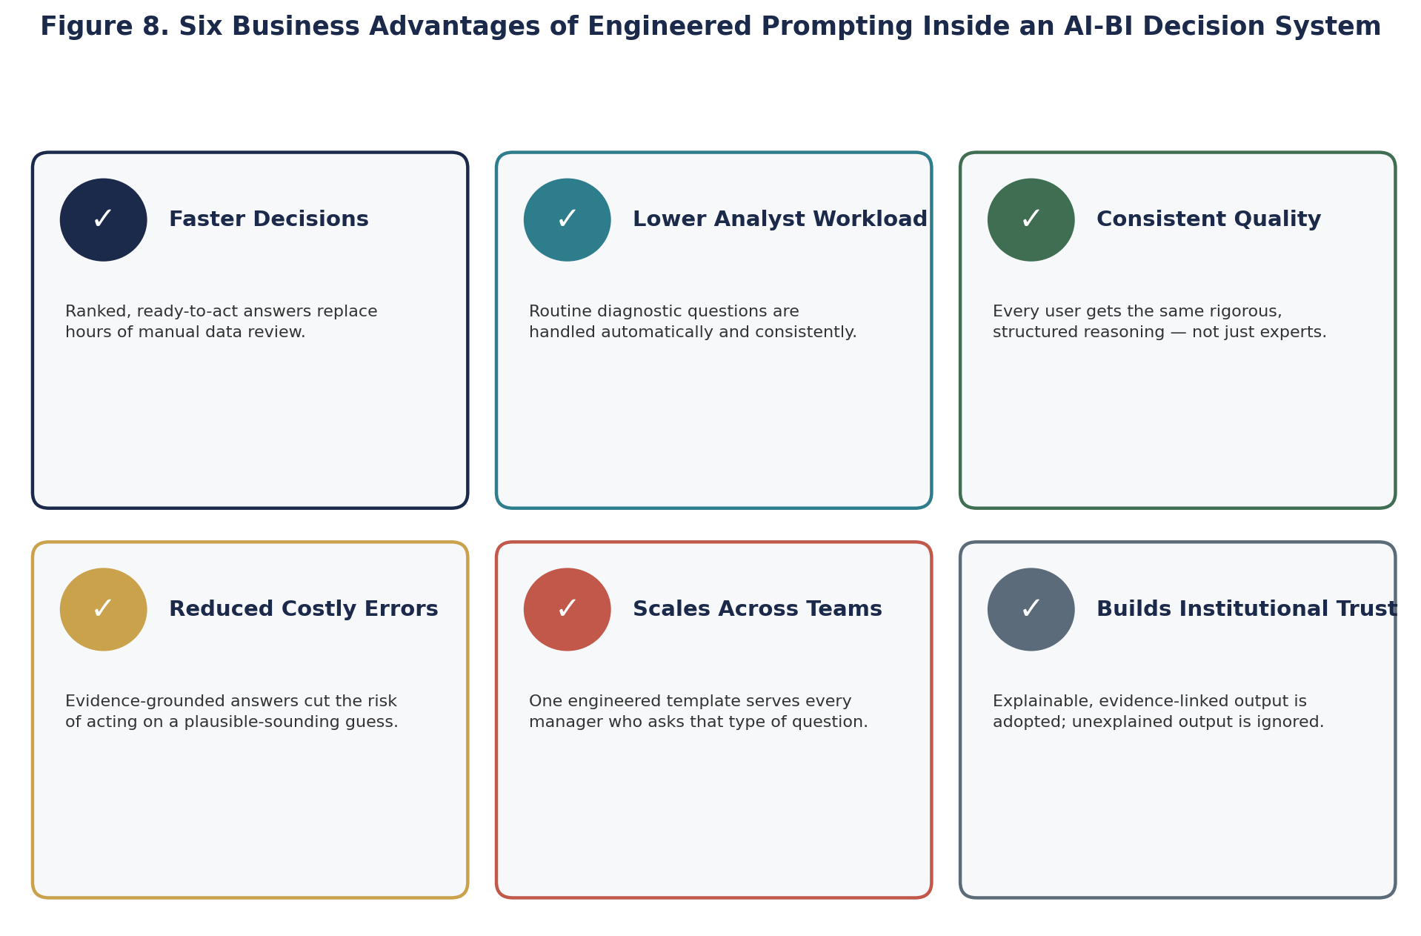
Figure 8. Six concrete business advantages that engineered prompting delivers when built into an AI-BI Decision System, each addressing a specific cost or risk of unstructured AI use.

10.1 Why This Is Necessary, Not Optional
Left ungoverned, generic prompting inside a business tends to fail quietly rather than obviously: managers receive plausible-sounding, generic answers, treat them as sufficient, and either make weaker decisions or fall back on manual analysis anyway — meaning the AI investment adds cost without removing the original workload. Engineered prompting is what converts an AI subscription into an actual productivity and decision-quality gain, which is precisely why it should be treated as required infrastructure for any organisation deploying an AI-BI Decision System, not an optional refinement added later.

11. Applying This Inside an AI-BI Decision System
Inside a full AI Business Intelligence and Decision System, prompt engineering is not something a business user does manually each time — it is built into the system itself as a template layer. When a manager asks a natural-language question through the system's interface, the system does not forward that question directly to the AI model. Instead, it automatically wraps the question in a pre-engineered template: injecting the relevant role, pulling the actual, current data relevant to the question from the data warehouse, adding the appropriate reasoning instruction for that type of decision, and enforcing a consistent output format.
This is what allows a non-technical manager to type a simple question and still receive a decision-ready answer — the prompt engineering work has already been done once, by the system's designers, and is applied automatically and consistently to every query of that type. The manager experiences a simple question-and-answer interaction; behind the scenes, the system is running the full engineered-prompt structure described in Section 4 every time.
SYSTEM DESIGN IMPLICATION
This means the real engineering work of an AI-BI Decision System is not the AI model itself — it is the library of engineered prompt templates built for each recurring business decision type (churn diagnosis, inventory reordering, campaign analysis, sales variance) and the pipeline that automatically fills each template with live business data.

12. Limitations and Risks
- Prompt engineering cannot compensate for missing or poor-quality data — an engineered prompt with wrong or incomplete context will produce a confident, well-structured, but wrong answer.
- Chain-of-thought reasoning increases token usage and response time compared to a generic prompt, which has real cost implications at scale.
- Published research (Zhang et al.) notes that the benefit of chain-of-thought prompting is smaller on already highly capable models — the technique is not a substitute for using a sufficiently capable underlying model.
- An engineered prompt template built for one type of business decision does not automatically generalise to another — each recurring decision type in Section 9 requires its own dedicated engineering and testing effort.
- Over-constraining the output format can occasionally suppress a genuinely important observation the model would otherwise have surfaced — format constraints must be validated, not just assumed to be strictly beneficial.

13. Conclusion
This chapter has argued and demonstrated, using real published research rather than assertion, that the difference between a generic and an engineered prompt is not a matter of style — it is measurably the difference between a system that talks about a topic and a system that solves a specific problem. A 40-percentage-point accuracy gain on a standard benchmark, produced by changing nothing but the prompt, is not a marginal effect; it is evidence that prompt engineering is one of the highest-leverage design decisions available when building an AI Business Intelligence and Decision System.
For a system to genuinely function as a decision partner rather than an answer machine, prompt engineering cannot be an afterthought left to individual users typing ad hoc questions. It must be treated as core system infrastructure: a maintained library of engineered prompt templates, built through the iterative process in Section 7, tested against real business cases, and automatically applied every time a decision-maker asks a question. That infrastructure — not the underlying AI model itself — is what ultimately determines whether the system produces a generic response or an actual solution.

References
Wei, J., Wang, X., Schuurmans, D., Bosma, M., Ichter, B., Xia, F., Chi, E., Le, Q., & Zhou, D. (2022). Chain-of-Thought Prompting Elicits Reasoning in Large Language Models. Advances in Neural Information Processing Systems 35 (NeurIPS 2022). Available at: https://arxiv.org/abs/2201.11903
Kojima, T., Gu, S. S., Reid, M., Matsuo, Y., & Iwasawa, Y. (2022). Large Language Models are Zero-Shot Reasoners. Advances in Neural Information Processing Systems 35 (NeurIPS 2022).
Henkel, O., Horne-Robinson, H., Dyshel, M., Ch, N., Moreau-Pernet, B., & Abood, R. (2024). Learning to Love Edge Cases in Formative Math Assessment: Using the AMMORE Dataset and Chain-of-Thought Prompting to Improve Grading Accuracy. Available at: https://arxiv.org/pdf/2409.17904
Zhao, R., et al. (2023). Verify-and-Edit: A Knowledge-Enhanced Chain-of-Thought Framework. Available at: https://arxiv.org/pdf/2305.03268
Anthropic. (2026). Prompt Engineering Overview. Available at: https://docs.claude.com/en/docs/build-with-claude/prompt-engineering/overview
This report was prepared as a conceptual and technical contribution on the topic of AI Business Intelligence and Decision Systems, focusing on prompt engineering as a problem-solving mechanism. The system diagrams, workflow, and business case study are original work developed for this submission; the accuracy figures cited in Sections 5 and the Executive Summary are drawn directly from the published research listed above.

